Software Design Document

Sydney Airbnb

Sabin Luitel (S5275468)  
Suzan Shrestha (S5279574)  
Ryan Chang Hee Kim (S5188533)

Table of Contents

1.0 System Vision 3

1.1 Problem Background 3

1.2 System Overview 3

1.3 Potential Benefits 3

2.0 Requirements 4

2.1 User Requirements 4

2.2 Software Requirements 4

2.3 Use Cases 4

3.0 System Components and Software Design 5

3.1 System Components 5

3.2 Software Design 5

4.0 User Interface Design 6

# System Vision

## Problem Background

The problem given has tasked us with implementing a software system that will analyse database containing a list of Sydney AirBnb properties in a CSV file. The data that is given are the listing information such as:

* ID, name, and address
* Property summary/details, type, size, amenities
* Host information
* Related reviews
* The availability and pricing
* Detailed information regarding the location such as a map and features.

.

## System Overview

The task is to display the listed information from the CSV files and display the information from the data that is given.

It will be running on a window for now and it will be coded through Python. It will help to store data efficiently. The system will allow the user to search the database, then the data will be called from the relating database.

* The results will show all related listings, suburbs and pricing in a readable format.
* Retrieve all results relating to the keyword/s entered by the user.
* Show availability of listings.

.

## Potential Benefits

This system should allow users to view Sydney AirBnb listings with ease, helping them decide which listing best suits their needs. Other benefits are:

* Less time to find related offences.
* Easy to analyse the group cases.
* It is easy to compare the data between different fiscal years.
* good management of data

# Requirements

## User Requirements

This system should be able to provide information about listed properties that are listed on Sydney Airbnb.

Data Storage: The recording of information in a storage media is known as data storage.

Formatting data: Data format is the organisation of data within a database or file system that gives the information significance.

Analysing data: It is the process of evaluating, cleaning, manipulating, and modelling data in order to identify usable information, inform conclusions, and help decision-making.

The data will then be display using two action, filtration, and analysis.  
once the data has been filtered and analysed, the data, suburb and keywords the display the listing information, price, and availability will be displayed.

## Software Requirements

**Operating System**: This software can be runed on Linux, macOS or windows.  
**Database Management System(DBMS):  
User Authentication and Authorization:**  
**Search and Filtering**: Implementing search and filtering functionalities to allow users to find properties based on criteria like location, price range, amenities, etc.  
**Reviews and Ratings:** Develop a system for users to leave reviews and ratings for properties and hosts.  
**Analytics and Monitoring**: Using some graphic for analytics and monitoring.  
**Version Control System:** Use a version control system Git for collaborative development and code management.  
**Backup and Disaster Recovery:** Implementing regular data backups and disaster recovery plans to protect against data loss.

* Functionality
* Performance
* External Interface
* Attributes
* Design constraints imposed on an implementation

## Use Cases & Use Case Diagrams

User can be device as Host and Guest.

1. User Registration and Login:

* Allow users to create accounts and log in.
* Actors: Guest, Host
* Users can register for an account using their email or social media accounts. They can also log in with their credentials.

1. Search for Properties:

* Guests search for properties to rent.
* Actors: Guest
* Guests can search for properties based on location, dates, price range, and other filters.

1. View Property Details:

* Guests view detailed information about a property.
* Actors: Guest
* Guests can click on a property listing to view photos, descriptions, amenities, and reviews.

1. Make Reservation:

* Guests make reservations for a property.
* Actors: Guest
* Guests can select a property, specify booking dates, and make a reservation.

1. Manage Property Listings:

* Hosts manage their property listings.
* Actors: Host
* Hosts can create, edit, or delete property listings. They can also update availability and pricing.

1. Accept/Reject Reservation Requests:

* Hosts manage reservation requests from guests.
* Actors: Host
* Hosts can accept or reject reservation requests based on availability and preferences.

1. Messaging between Host and Guest:

* Hosts and guests communicate with each other.
* Actors: Host, Guest
* Hosts and guests can send messages to discuss booking details, ask questions, and coordinate.

1. Leave Reviews and Ratings:

* Guests and hosts leave reviews and ratings.
* Actors: Guest, Host
* After a stay, guests and hosts can leave reviews and ratings for each other.

1. Payment Processing:

* Process payments for reservations.
* Actors: Guest, Host, Payment Gateway
* The system handles payment processing securely, deducting fees and transferring funds to hosts.

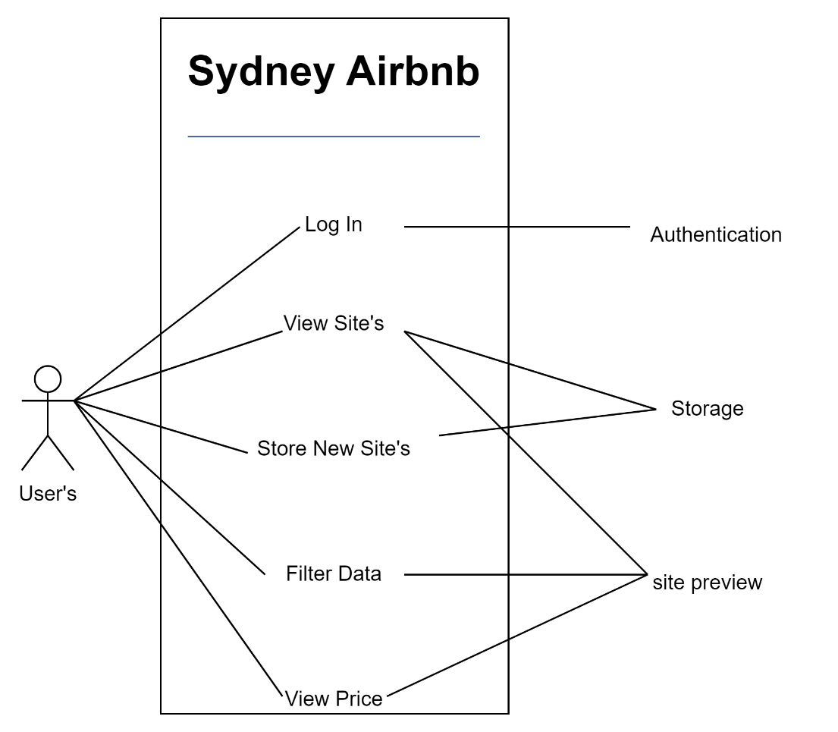

# Software Design and System Components

## Software Design

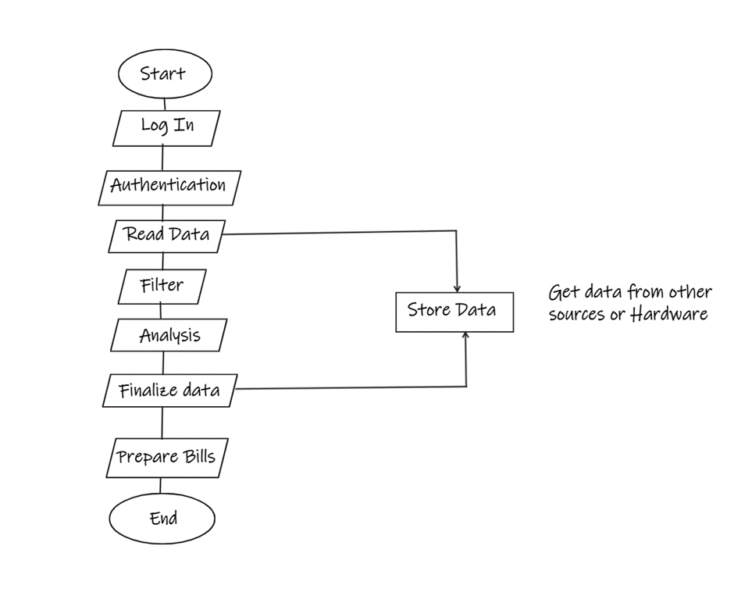

## System Components

### Functions

* Hardware is assigned to applications based on their requirements.
* Schedule the programmes on the CPU for linear and methodical execution.
* Memory is assigned to each individual application based on the requirements of the programme.
* Programs' input and output devices are assigned one at a time.
* There, user contact is accomplished by recognising the user's expectations and requirements and reacting to them with a suitable message or task.
* All programme and data files are managed and kept on secondary storage devices.
* The file directories existent in memory are retained, and access to the files' data is granted.
* Maintain software-user coordination by allocating, assigning, and providing assemblers, compilers, memory, interpreters, and other resources.
* Maintaining system security and access privileges to diverse system resources

### Data Structures / Data Sources

Data structures are abstract structures that are arranged in a certain way and are used to organise data and perform different operations on it. Data structures vary in their suitability for various applications, and some are highly specialised to certain tasks.

The Type of structure are:

1. Record: It is a fixed number and sequence and typically indexed by names.
2. Union: It is a data structure that specifies which of several permitted primitive types may be stored in its instances, e.g., float or long integer.
3. Set: It can store specific values with no duplicate value.
4. Graph and a tree: It linked abstract data structures composed of nodes. Each node contains a value and one or more pointers to other nodes arranged in a hierarchy.
5. Class: It contains data fields, like a record, as well as various methods which operate on the contents of the record.

### Detailed Design

The materials engineering perspective is required for the following parts of the detail design phase:

* Choosing bespoke subassemblies and components providers
* Choosing commercially available subassemblies and components
* completing bespoke subassemblies and components design
* Creating manufacturing processes
* Completing requirements for subassemblies, components, materials, and production processes
* Performing product verification tests

# User Interface Design

First there will be a login page for user to login. Then they will be directed to the home page.

Home page will contain the search bar where they can search any types of place user is looking to stay form the database. Home page will contain the logo of the company on top-middle of screen. Home page will contain one filter option where user can filter the data according to their needs (for e.g. Time, date or the types of building, suburb). User can go through the available data without searching as well.

## Structural Design

1. Homepage:

Airbnb's homepage serves as the gateway to the platform. It features a search bar prominently, encouraging users to begin their search immediately.

Information is grouped hierarchically with a clear emphasis on the primary action: searching for properties.

1. Navigation Bar:

Located at the top of each page, the navigation bar provides easy access to essential sections: Home, Host, Experiences, Restaurants, and more.

User account-related actions are also accessible here (e.g., profile, saved trips).

1. Search Results Page:

After initiating a search, users are presented with a grid of property listings. Listings are grouped by relevance to the search criteria.

Filters on the left side allow users to refine their search results, grouping information by criteria such as location, price, property type, and amenities.

1. Property Listing Page:

Individual property listings provide detailed information about a specific property. Information is grouped into sections such as photos, description, amenities, reviews, and host details.

A clear call to action is provided for booking the property.

1. User Profile:

User profiles are structured to display a user's personal information, hosted listings, reviews, and saved trips.

Information is grouped to offer an overview of a user's activity on Airbnb.

1. Booking Process:

The booking process is designed step by step, guiding users through information input, reservation details, payment, and confirmation.

Information is grouped logically to ensure a smooth booking experience.

If software gives a computer the instructions it needs to execute a task, software structure design is the path the programme takes to do so. It's vital to remember that an architectural pattern isn't a finished design that can be plugged in; rather, it's a template that can be manipulated to address issues in a variety of settings.

## Visual Design

Top right corner that is user icon which shows who is login and from there user can change their personal details and password also.

There is search bar for user to search particular info they are looking for. And filter bottom to filter the data according to needs.

Bellow the search bar that’s where the data can be found.

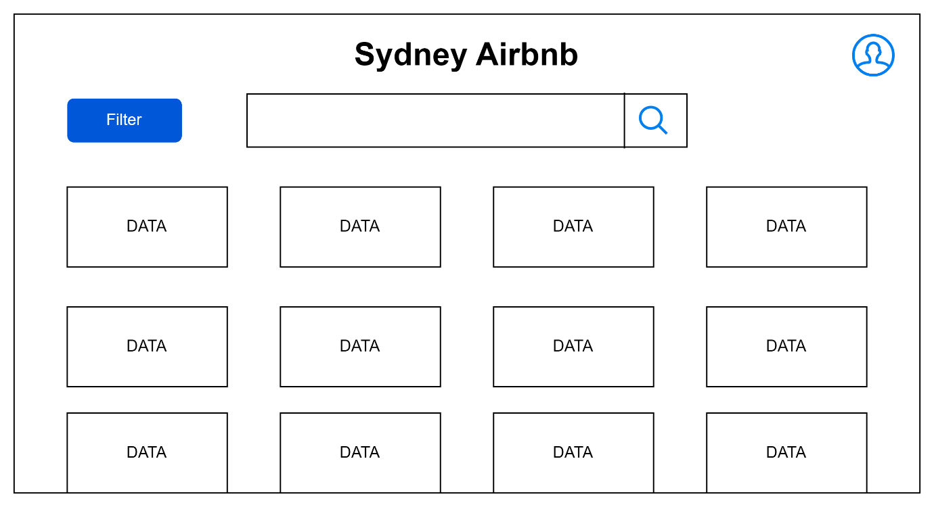

When you click on any data then it will take you to that particular data with enough info you need for that building.

